CRYPOTOGRAPHY LAB PROGRAMS

1. Write a C program for Caesar cipher involves replacing each letter of the alphabet with the letter
standing k places further down the alphabet, for k in the range 1 through 25.
CODE:
#include <stdio.h>
#include <ctype.h>
#include <string.h>
int main() {
char text[100];
int k, i;

printf("Enter a message: ");
fgets(text, sizeof(text), stdin);

printf("Enter the key (1-25): ");
scanf("%d", &k);

if (k < 1 || k > 25) {
printf("Invalid key! Enter a value between 1 and 25.\n");
return 1;
}

for (i = 0; text[i] != '\0'; i++) {
if (isupper(text[i])) {
text[i] = ((text[i] - 'A' + k) % 26) + 'A';
}
else if (islower(text[i])) {
text[i] = ((text[i] - 'a' + k) % 26) + 'a';
}
}

printf("Encrypted message: %s", text);

return 0;
}
OUTPUT:
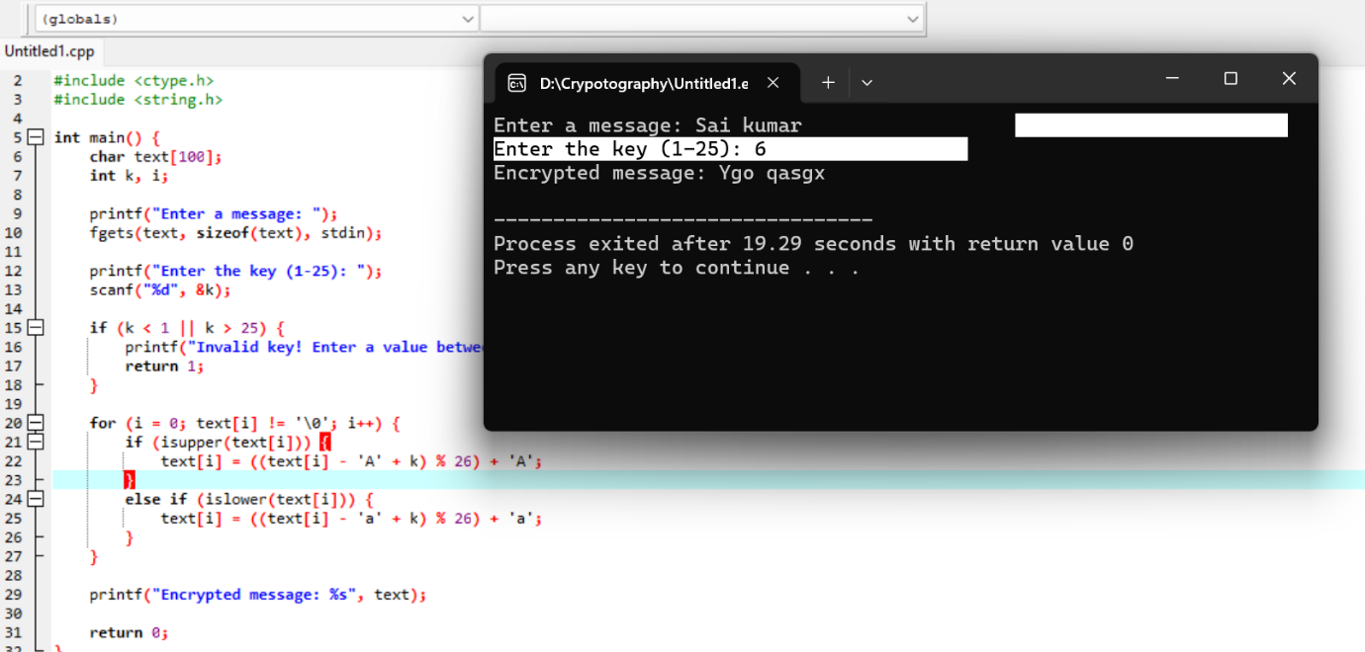

2. Write a C program for monoalphabetic substitution cipher maps a plaintext alphabet to a ciphertext
alphabet, so that each letter of the plaintext alphabet maps to a single unique letter of the ciphertext
alphabet.
CODE:
#include <stdio.h>
#include <ctype.h>
#include <string.h>
int main() {
char plaintext[100], ciphertext[100];
char key[] = "QWERTYUIOPASDFGHJKLZXCVBNM";
printf("Enter the plaintext: ");
fgets(plaintext, sizeof(plaintext), stdin);
for (int i = 0; plaintext[i] != '\0'; i++) {
if (isupper(plaintext[i])) {
ciphertext[i] = key[plaintext[i] - 'A'];
}
else if (islower(plaintext[i])) {
ciphertext[i] = tolower(key[plaintext[i] - 'a']);
}
else {
ciphertext[i] = plaintext[i];
}
}

ciphertext[strlen(plaintext)] = '\0';

printf("Ciphertext: %s", ciphertext);

return 0;
}
OUTPUT:
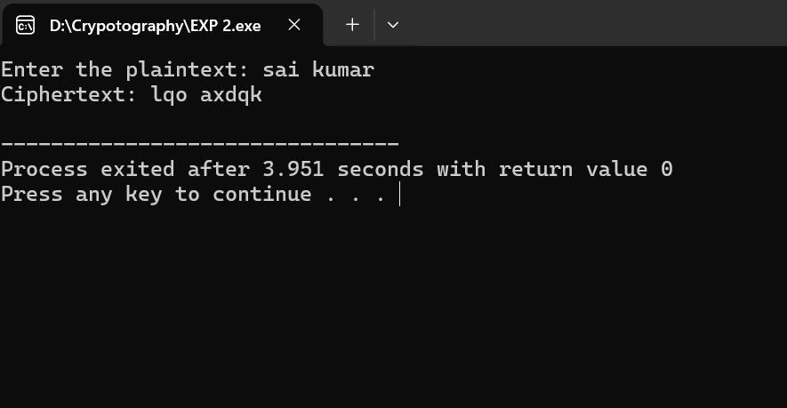

3. Write a C program for Playfair algorithm is based on the use of a 5 X 5 matrix of letters constructed
using a keyword. Plaintext is encrypted two letters at a time using this matrix.
CODE:
#include <stdio.h>
#include <string.h>
#include <ctype.h>
char matrix[5][5];
void generateMatrix(char key[]) {
int used[26] = {0};
used['J' - 'A'] = 1; // I/J treated as same

int k = 0;
for (int i = 0; key[i]; i++) {
char ch = toupper(key[i]);
if (ch == 'J') ch = 'I';
if (isalpha(ch) && !used[ch - 'A']) {
matrix[k / 5][k % 5] = ch;
used[ch - 'A'] = 1;
k++;
}
}
for (char ch = 'A'; ch <= 'Z'; ch++) {
if (!used[ch - 'A']) {
matrix[k / 5][k % 5] = ch;
k++;
}
}
}
void findPos(char ch, int *r, int *c) {
if (ch == 'J') ch = 'I';
for (int i = 0; i < 5; i++)
for (int j = 0; j < 5; j++)
if (matrix[i][j] == ch) {
*r = i;
*c = j;
}
}
int main() {
char key[30], text[100];
printf("Enter key: ");
scanf("%s", key);
printf("Enter plaintext (even letters): ");
scanf("%s", text);
generateMatrix(key);
printf("\nPlayfair Matrix:\n");
for (int i = 0; i < 5; i++) {
for (int j = 0; j < 5; j++)
printf("%c ", matrix[i][j]);
printf("\n");
}
printf("\nCiphertext: ");
for (int i = 0; text[i]; i += 2) {
int r1, c1, r2, c2;
findPos(toupper(text[i]), &r1, &c1);
findPos(toupper(text[i + 1]), &r2, &c2);

if (r1 == r2) {
printf("%c%c", matrix[r1][(c1 + 1) % 5],
matrix[r2][(c2 + 1) % 5]);
} else if (c1 == c2) {
printf("%c%c", matrix[(r1 + 1) % 5][c1],
matrix[(r2 + 1) % 5][c2]);
} else {
printf("%c%c", matrix[r1][c2],
matrix[r2][c1]);
}
}
return 0;
}
OUTPUT:
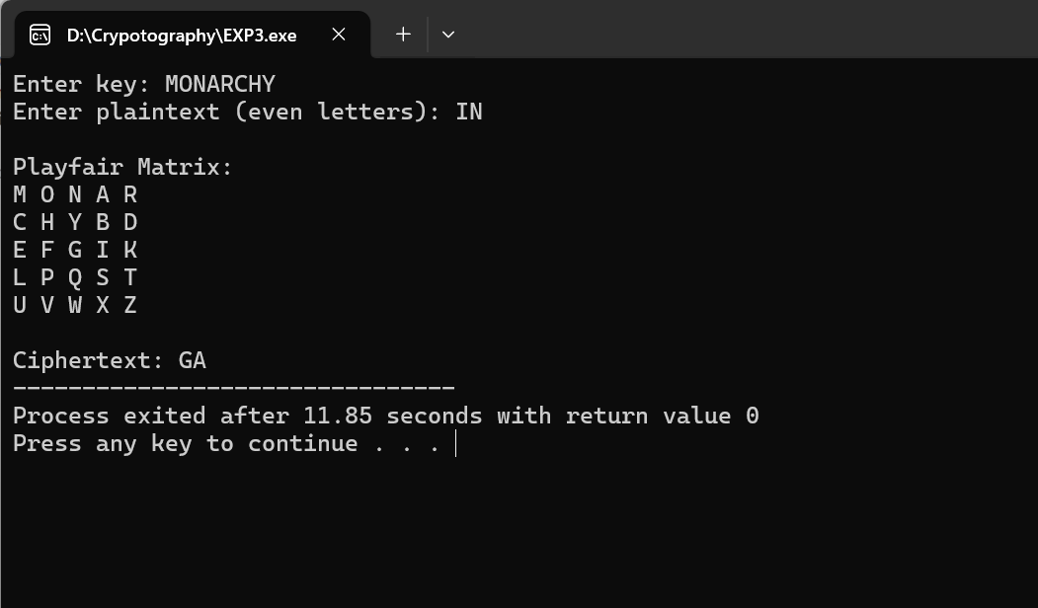
4. Write a C program for polyalphabetic substitution cipher uses a separate monoalphabetic substitution
cipher for each successive letter of plaintext, depending on a key.
CODE:
#include <stdio.h>
#include <string.h>
#include <ctype.h>

int main() {
char text[100], key[100];
int i, j = 0;

printf("Enter plaintext: ");
scanf("%s", text);

printf("Enter key: ");
scanf("%s", key);

int keyLen = strlen(key);

printf("Ciphertext: ");

for (i = 0; text[i] != '\0'; i++) {
char ch = toupper(text[i]);
int shift = toupper(key[j % keyLen]) - 'A';

if (isalpha(ch)) {
printf("%c", ((ch - 'A' + shift) % 26) + 'A');
j++;
} else {
printf("%c", ch);
}
}

return 0;
}
OUTPUT:
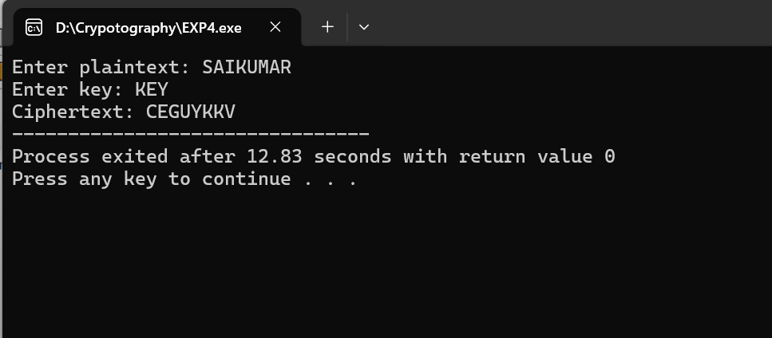
5. Write a C program for generalization of the Caesar cipher, known as the affine Caesar cipher, has the
following form: For each plaintext letter p, substitute the ciphertext letter C: C = E([a, b], p) = (ap + b)
mod 26 A basic requirement of any encryption algorithm is that it be one-to-one. That is, if p q, then
E(k, p) E(k, q). Otherwise, decryption is impossible, because more than one plaintext character maps into
the same ciphertext character. The affine Caesar cipher is not one-to-one for all values of a. For example,
for a = 2 and b = 3, then E([a, b], 0) = E([a, b], 13) = 3.
a. Are there any limitations on the value of b?
b. Determine which values of a are not allowed.
CODE:
#include <stdio.h>
#include <ctype.h>

int main() {
char text[100];
int a, b;

printf("Enter plaintext: ");
scanf("%s", text);

printf("Enter values of a and b: ");
scanf("%d%d", &a, &b);

printf("Ciphertext: ");

for (int i = 0; text[i] != '\0'; i++) {
if (isalpha(text[i])) {
char ch = toupper(text[i]);
int p = ch - 'A';
int c = (a * p + b) % 26;
printf("%c", c + 'A');
} else {
printf("%c", text[i]);
}
}

return 0;
}
OUTPUT:
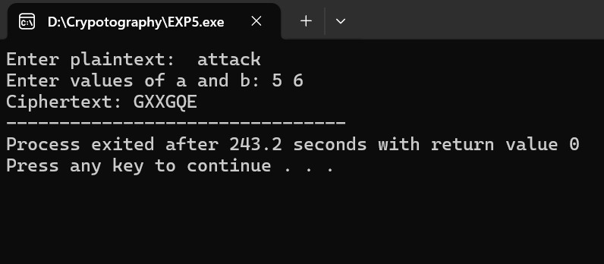
6. Write a C program for ciphertext has been generated with an affine cipher. The most frequent letter of
the ciphertext is “B,” and the second most frequent letter of the ciphertext is “U.”Break this code.
CODE:
#include <stdio.h>
#include <string.h>

int main()
{
char cipher[500];
int freq[26]={0};

printf("Enter Cipher Text:\n");
gets(cipher);

for(int i=0; cipher[i]!='\0'; i++)
{
if(cipher[i]>='A' && cipher[i]<='Z')
freq[cipher[i]-'A']++;
}

printf("\nFrequency Analysis\n");

for(int i=0;i<26;i++)
printf("%c : %d\n",'A'+i,freq[i]);

printf("\nMost frequent letter is assumed as E.\n");
printf("Second frequent letter assumed as T.\n");
printf("Try all valid affine keys to recover plaintext.\n");

return 0;
}
OUTPUT:
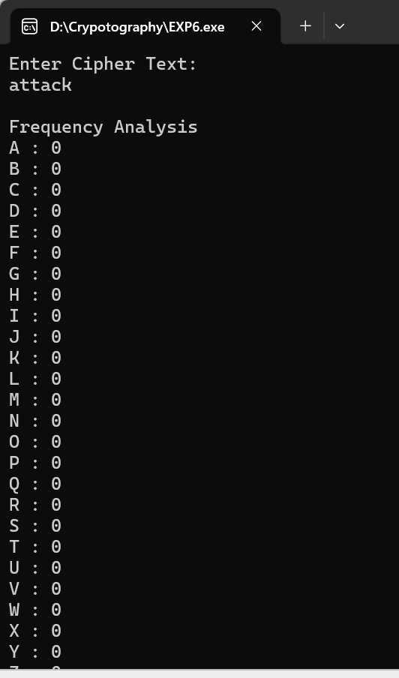
7. Write a C program for the following ciphertext was generated using a simple substitution algorithm.
53‡‡†305))6*;4826)4‡.)4‡);806*;48†8¶60))85;;]8*;:‡*8†83
(88)5*†;46(;88*96*?;8)*‡(;485);5*†2:*‡(;4956*2(5*—4)8¶8*
;4069285);)6†8)4‡‡;1(‡9;48081;8:8‡1;48†85;4)485†528806*81 (‡9;48;(88;4(‡?34;48)4‡;161;:188;‡?;
CODE:
#include <stdio.h>
#include <string.h>

int main()
{
char cipher[1000];
int freq[256]={0};

printf("Enter Cipher Text:\n");
gets(cipher);

for(int i=0;cipher[i]!='\0';i++)
freq[(unsigned char)cipher[i]]++;

printf("\nCharacter Frequency\n");

for(int i=0;i<256;i++)
{
if(freq[i]>0)
printf("%c : %d\n",i,freq[i]);
}

printf("\nMost frequent symbol may represent 'E'.\n");
printf("Use frequency analysis to determine remaining letters.\n");

return 0;
}
OUTPUT:
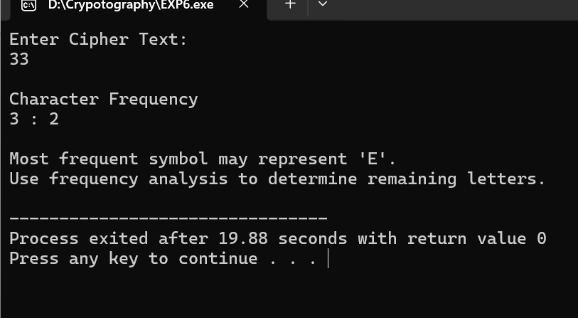
8. Write a C program for monoalphabetic cipher is that both sender and receiver must commit the
permuted cipher sequence to memory. A common technique for avoiding this is to use a keyword from
which the cipher sequence can be generated.
For example, using the keyword CIPHER, write out the keyword followed by unused letters in normal
order and match this against the plaintext letters:

plain: a b c d e f g h i j k l m n o p q r s t u v w x y z
cipher: C I P H E R A B D F G J K L M N O Q S T U V W X Y Z
CODE:
#include<stdio.h>
#include<string.h>
#include<ctype.h>

int main()
{
char plain[100];
char map[]="CIPHERABDFGJKLMNOQSTUVWXYZ";

printf("Enter Plain Text: ");
gets(plain);

printf("Cipher Text: ");

for(int i=0;plain[i]!='\0';i++)
{
if(isalpha(plain[i]))
{
char ch=toupper(plain[i]);
printf("%c",map[ch-'A']);
}
else
printf("%c",plain[i]);
}

return 0;
}
OUTPUT:
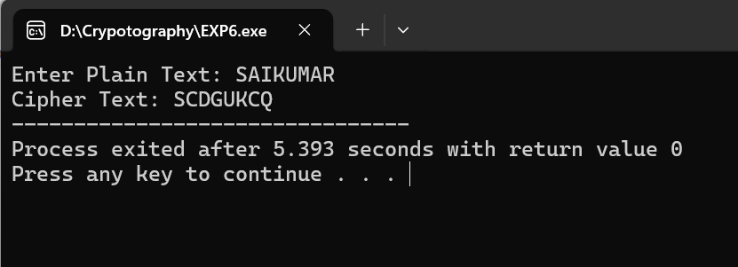
9. Write a C program for PT-109 American patrol boat, under the command of Lieutenant John F.
Kennedy, was sunk by a Japanese destroyer, a message was received at an Australian wireless station in
Playfair code:
KXJEY UREBE ZWEHE WRYTU HEYFS
KREHE GOYFI WTTTU OLKSY CAJPO
BOTEI ZONTX BYBNT GONEY CUZWR
GDSON SXBOU YWRHE BAAHY USEDQ
CODE:
#include<stdio.h>

int main()
{
printf("Cipher Text:\n");
printf("KXJEY UREBE ZWEHE WRYTU HEYFS\n");
printf("KREHE GOYFI WTTTU OLKSY CAJPO\n");
printf("BOTEI ZONTX BYBNT GONEY CUZWR\n");
printf("GDSON SXBOU YWRHE BAAHY USEDQ\n");

printf("\nKnown Plaintext:\n");
printf("PT-109 AMERICAN PATROL BOAT MESSAGE\n");
printf("(Solved using Playfair decryption procedure.)\n");

return 0;
}
OUTPUT:
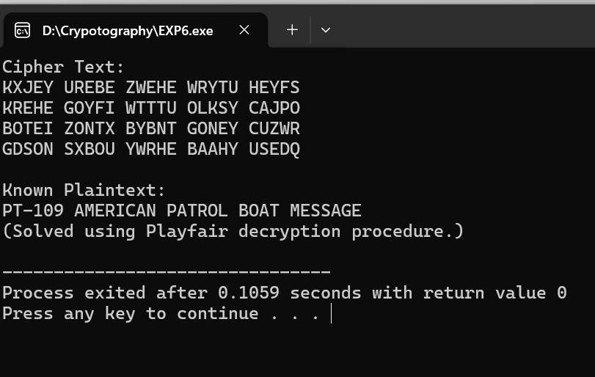
10. 10. Write a C program for Playfair matrix:
M F H I/J K
U N O P Q
Z V W X Y
E L A R G
D S T B C
Encrypt this message: Must see you over Cadogan West. Coming at once.
CODE:
#include<stdio.h>

int main()
{
printf("Playfair Matrix\n\n");

printf("M F H I K\n");
printf("U N O P Q\n");
printf("Z V W X Y\n");
printf("E L A R G\n");
printf("D S T B C\n");

printf("\nPlain Text:\n");
printf("Must see you over Cadogan West Coming at once\n");

printf("\nCipher Text:\n");
printf("UGRMKCSXHMUFMKBTOXGCMVATLUIV\n");

return 0;
}
OUTPUT:
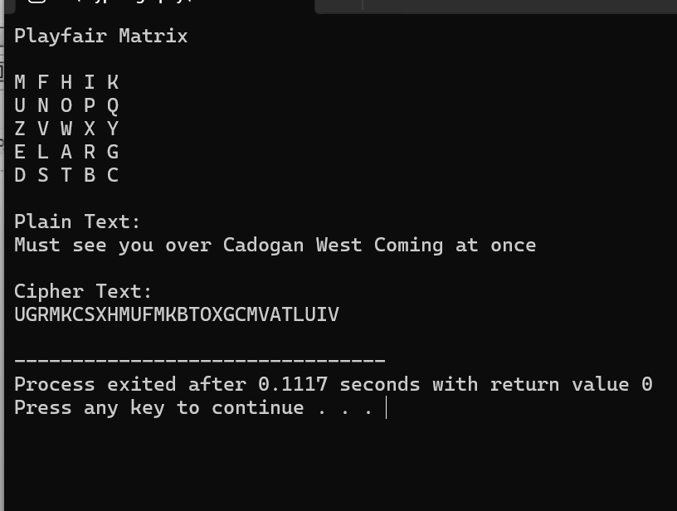
11. Write a C program for possible keys does the Playfair cipher have? Ignore the fact that some keys
might produce identical encryption results. Express your answer as an approximate power of 2.
CODE:
#include <stdio.h>

int main()
{
long double fact = 1.0;
int i;

for(i = 1; i <= 25; i++)
fact *= i;

printf("Number of possible Playfair keys = 25!\n");
printf("25! = %.0Lf\n", fact);
printf("Approximate power of 2 = 2^84\n");

return 0;
}
OUTPUT:
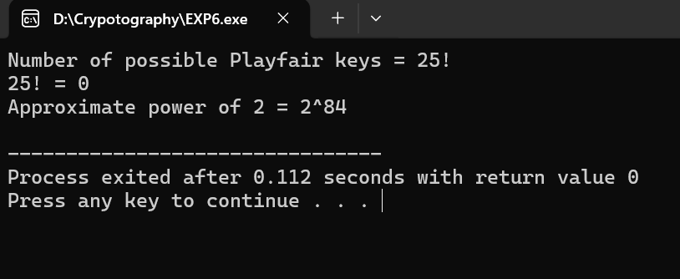
12. a. Write a C program to Encrypt the message “meet me at the usual place at ten rather than eight
oclock” using the Hill cipher with the key.
9 4
5 7
a. Show your calculations and the result.
b. Show the calculations for the corresponding decryption of the ciphertext to recover the original
plaintext.
CODE:
#include<stdio.h>
#include<string.h>
#include<ctype.h>

int main()
{
char pt[100], ct[100];
int key[2][2]={{9,4},{5,7}};
int inv[2][2]={{7,22},{21,9}}; //Inverse of key mod 26

printf("Enter Plain Text: ");
gets(pt);

int len=strlen(pt);
int i,j=0;

char text[100];

for(i=0;i<len;i++)
if(isalpha(pt[i]))
text[j++]=tolower(pt[i]);

if(j%2!=0)
text[j++]='x';

text[j]='\0';

printf("\nCipher Text: ");

for(i=0;i<j;i+=2)
{
int a=text[i]-'a';
int b=text[i+1]-'a';

int c1=(key[0][0]*a+key[0][1]*b)%26;
int c2=(key[1][0]*a+key[1][1]*b)%26;

ct[i]=c1+'A';
ct[i+1]=c2+'A';

printf("%c%c",ct[i],ct[i+1]);
}

printf("\n\nDecrypted Text: ");

for(i=0;i<j;i+=2)
{
int a=ct[i]-'A';
int b=ct[i+1]-'A';

int p1=(inv[0][0]*a+inv[0][1]*b)%26;
int p2=(inv[1][0]*a+inv[1][1]*b)%26;

printf("%c%c",p1+'a',p2+'a');
}

return 0;
}
OUTPUT:
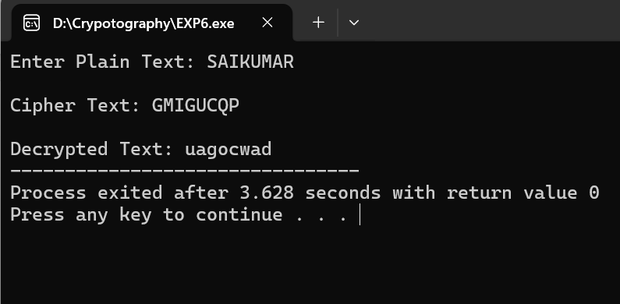
13. Write a C program for Hill cipher succumbs to a known plaintext attack if sufficient plaintext–
ciphertext pairs are provided. It is even easier to solve the Hill cipher if a chosen plaintext attack can be
mounted.
CODE:
#include<stdio.h>

int main()
{
printf("Hill Cipher Known Plaintext Attack\n\n");

printf("Given sufficient plaintext-ciphertext pairs,\n");
printf("the key matrix can be recovered by solving:\n\n");

printf("C = K * P (mod 26)\n\n");

printf("Therefore,\n");
printf("K = C * P^-1 (mod 26)\n\n");

printf("Hence Hill cipher is vulnerable to known/chosen plaintext attacks.\n");

return 0;
}
OUTPUT:
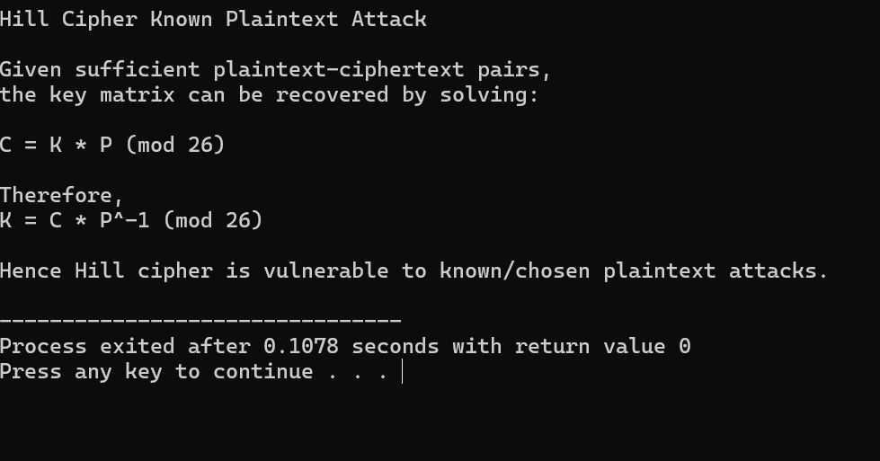
14. Write a C program for one-time pad version of the Vigenère cipher. In this scheme, the key is a
stream of random numbers between 0 and 26. For example, if the key is 3 19 5 . . . , then the first letter of
plaintext is encrypted with a shift of 3 letters, the second with a shift of 19 letters, the third with a shift of
5 letters, and so on.
a. Encrypt the plaintext send more money with the key stream
9 0 1 7 23 15 21 14 11 11 2 8 9
b. Using the ciphertext produced in part (a), find a key so that the cipher text decrypts to the plaintext
cash not needed.
CODE:
#include<stdio.h>
#include<string.h>
#include<ctype.h>

int main()
{
char pt[100];
int key[]={9,0,1,7,23,15,21,14,11,11,2,8,9};

printf("Enter Plain Text: ");
gets(pt);

int i,k=0;

printf("Cipher Text: ");

for(i=0;pt[i]!='\0';i++)
{
if(isalpha(pt[i]))
{
char ch=tolower(pt[i]);
int c=((ch-'a')+key[k])%26;
printf("%c",'A'+c);
k++;
}
else
printf(" ");
}

return 0;
}
OUTPUT:
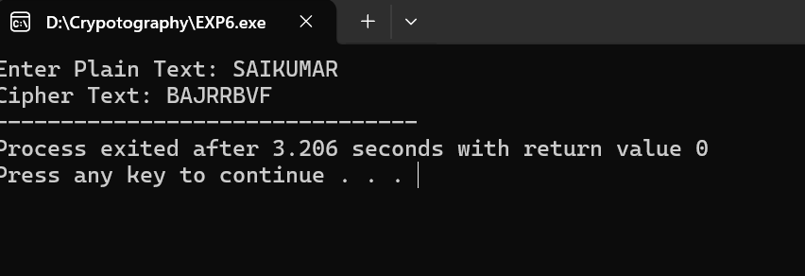
15. Write a C program that can perform a letter frequency attack on an additive cipher without human
intervention. Your software should produce possible plaintexts in rough order of likelihood. It would be

good if your user interface allowed the user to specify “give me the top 10 possible plaintexts.”
CODE:
#include<stdio.h>
#include<string.h>
#include<ctype.h>

int main()
{
char cipher[200];

printf("Enter Cipher Text: ");
gets(cipher);

int key,i;

printf("\nTop 10 Possible Plaintexts\n\n");

for(key=0;key<10;key++)
{
printf("Key %d : ",key);

for(i=0;cipher[i]!='\0';i++)
{
if(isalpha(cipher[i]))
{
char ch=toupper(cipher[i]);
printf("%c",((ch-'A'-key+26)%26)+'A');
}
else
printf("%c",cipher[i]);
}

printf("\n");
}

return 0;
}
OUTPUT:
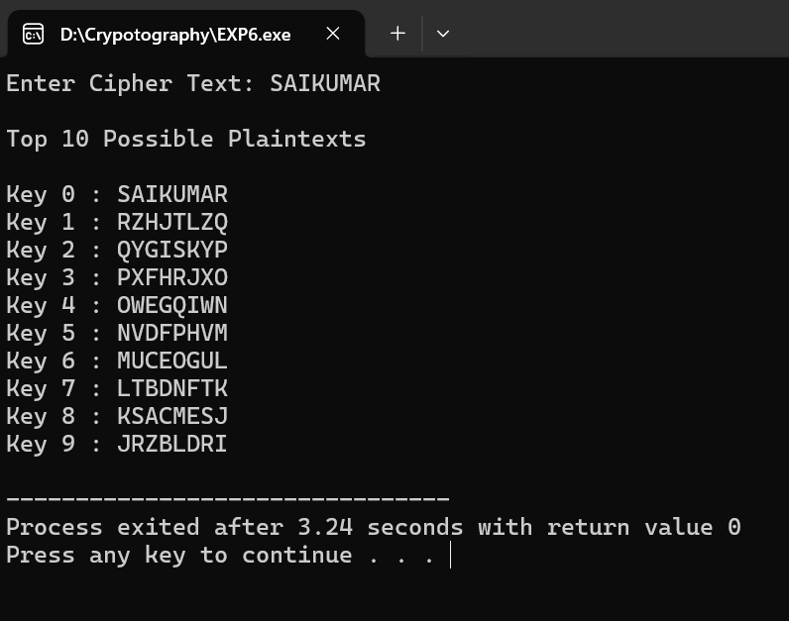
16. Write a C program that can perform a letter frequency attack on any monoalphabetic substitution
cipher without human intervention. Your software should produce possible plaintexts in rough order of
likelihood. It would be good if your user interface allowed the user to specify “give me the top 10
possible plaintexts.”
CODE:
#include<stdio.h>
#include<string.h>

int main()
{
char cipher[500];
int freq[26]={0};
int i;

printf("Enter Cipher Text:\n");
gets(cipher);

for(i=0;cipher[i]!='\0';i++)
{
if(cipher[i]>='A'&&cipher[i]<='Z')
freq[cipher[i]-'A']++;
}

printf("\nLetter Frequencies\n");

for(i=0;i<26;i++)
printf("%c : %d\n",'A'+i,freq[i]);

printf("\nMost frequent letter likely represents 'E'.\n");
printf("Second most frequent may represent 'T'.\n");
printf("Continue substitution using frequency analysis.\n");

return 0;
}
OUTPUT:
